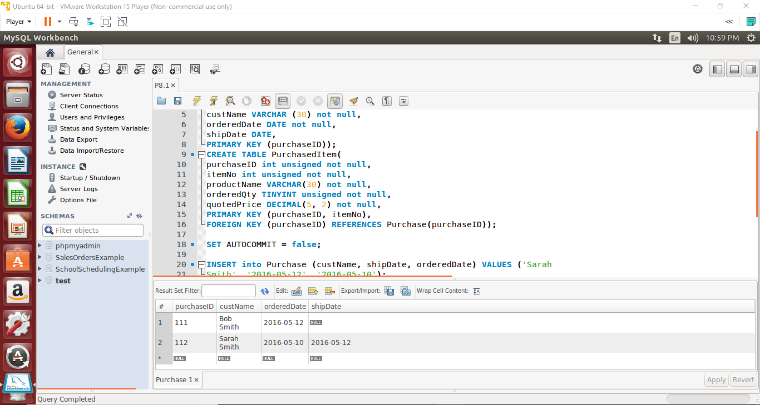

The statement uses the autoincrement, and the number created should be the next up, which is 112.

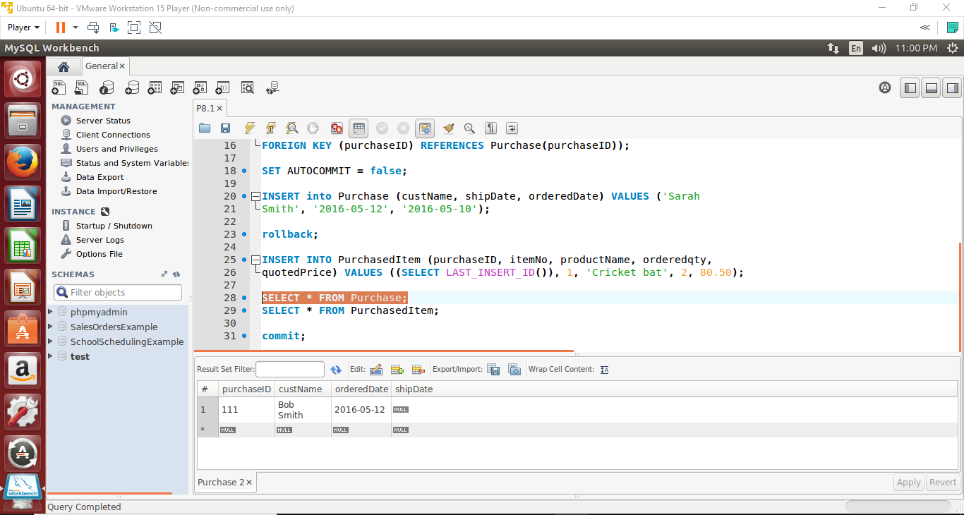

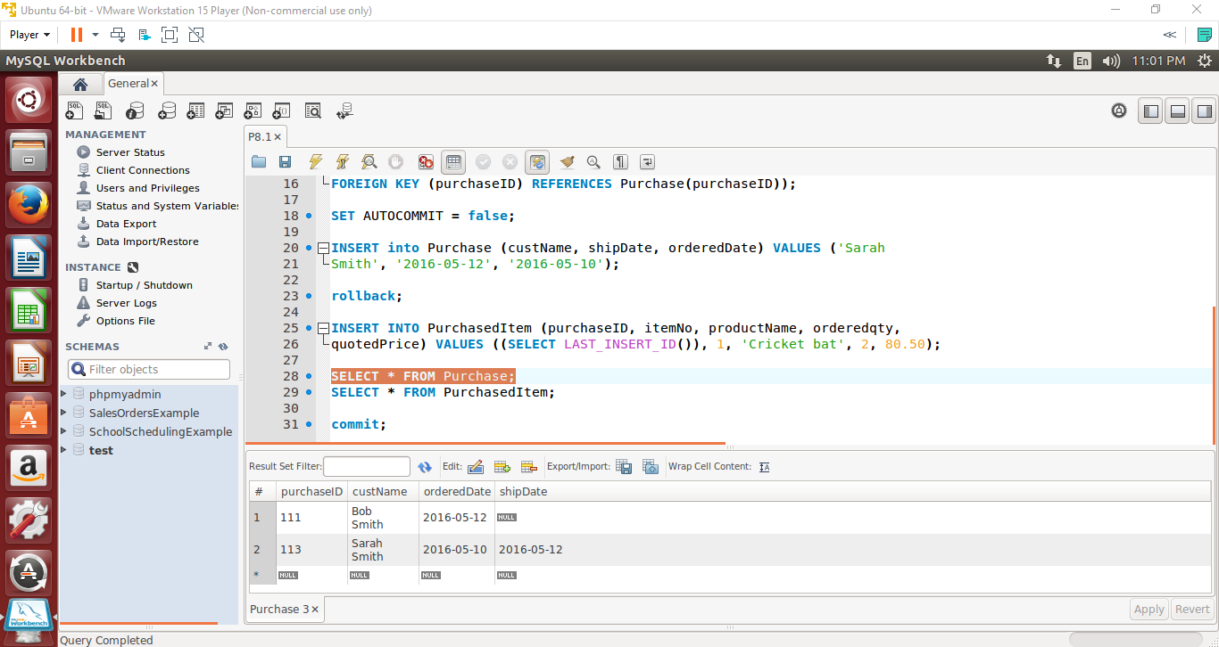

Rolling back the statement means losing the number 112, which will be replaced by 113 when the statement is run again.

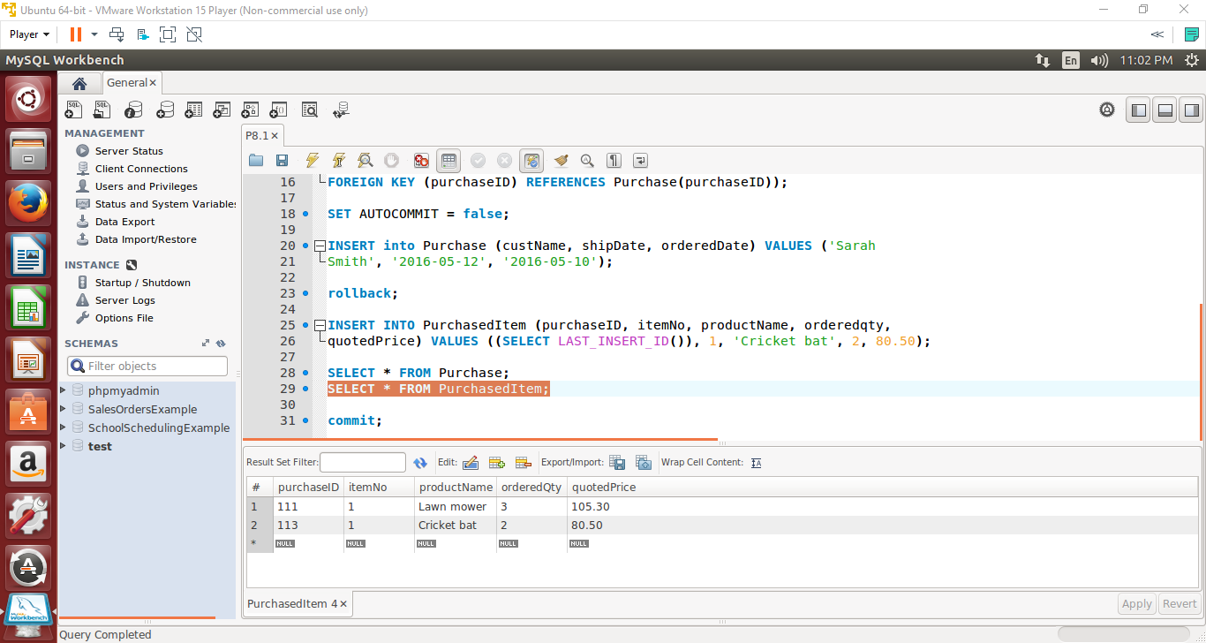

? was substituted to SELECT LAST_INSERT_ID(). This would make the productID correspond to the purchaseID. In this case, the purchaseID in the Purchase table is the primary key and productID in PurchasedItem table is the foreign key.